Abstract— The Carbon credit trading platform mainly aims at reducing carbon dioxide and other greenhouse gas levels in the environment which is produced by any industries beyond the limit. carbon credit means granting permission to produce carbon dioxide and other greenhouse gases up to a certain limit (generally up to 1 ton of GHG). This project mainly aims to buy, sell, and trade carbon credits in the blockchain network and also focuses on producing renewable energies, rebalancing enough amount of GHG to other gases, etc. The usage of blockchain networks includes working on smart contracts, wallets, cryptocurrencies, etc.
Carbon-credit Trading platform using Blockchain technology

keywords: carbon credits, permissions, greenhouse gases, blockchain, smart contracts.

INTRODUCTION
ACarbon credit is a thing where the supplier sells to the voluntary (at times involuntary too) buyer of carbon credit by giving some money. This can also be traded between parties. Carbon credits aim to reduce the emission of GHG by increasing its absorption. As a responsible person, we must aim to keep the earth’s temperature low to survive and ensure life in the future. According to the Kyoto Protocol of 1992, carbon credits came into function. Which overall aims at reducing the emission of 6 GHG – carbon dioxide, methane, nitrous oxide, hydrofluorocarbons, perfluorocarbons, and sulfur hexafluoride
These days there is a drastic change in the climate, it is not what it used to be like, large ice-caps at the poles are melted down, implying an increase in the sea level, change in humidity, varied raining timings, etc. This is due to an increase in GHG in the atmosphere. Although this is happening because of large industries, vehicles, etc. Also, we cannot avoid them as they have become essential parts of life. We can't spend our time going to the office by walking or through public transport (minimal GHG release).
So, we can alternately increase the absorption of CO2 or other GHG by some positive activities like initiating afforestation, usage of renewable energies, etc. As someone who is concerned about the environment, we are introducing the carbon credit trading platform where anyone can trade the carbon credit. The existing system has some limitations like lacking transparency and some security concerns which means the major industries may have limited accessibilities where they may not be allowed to buy as a single person or may have any other restrictions.
The specialty of our carbon credit trading platform is that it uses blockchain, where when each carbon credit is bought, we tokenize it and then use it for building renewable resources. This trading platform works on the Ethereum blockchain network which makes it more unique and increases the easiness of the transaction. This work contributes to sustainable practices and tries to combat climate challenges.

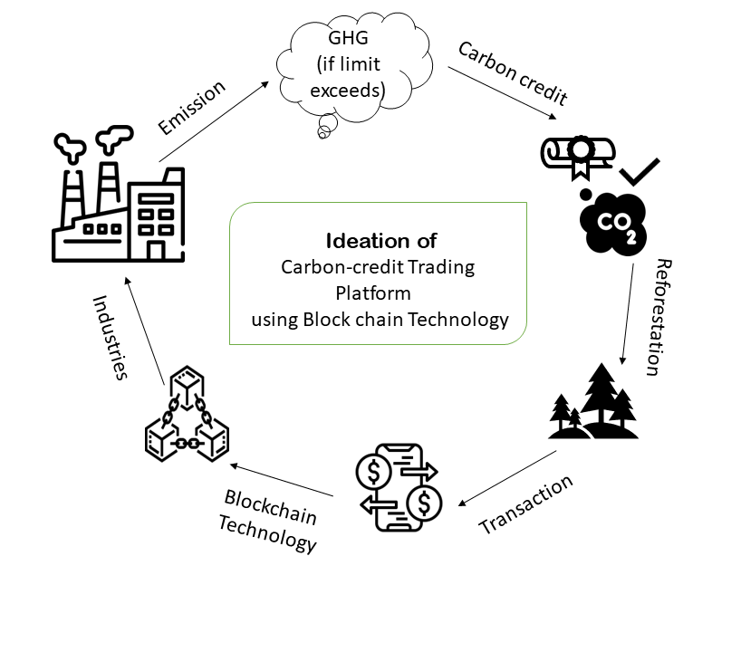
Figure 1-Ideation of Carbon credit trading platform

Methodology

Requirement Analysis
There are certain requirements to this trading platform, some of the hardware and software requirements are:
• Processor: A modern multi-core processor (e.g., Intel Core i5 or AMD Ryzen series) for smooth performance.
• RAM: At least 8GB of RAM for running development environments and compiling smart contracts.
• Storage: Sufficient storage space (at least 100GB) for storing development tools, libraries, and project files.
• Internet Connection: A stable internet connection for downloading dependencies, accessing APIs, and deploying smart contracts.
• Operating System: Windows, macOS, or Linux operating system.
• Development Environment: Here we are using Visual Studio code to run the applications.
• Node.js: It is used to run applications based on JavaScript.
• Ganache: This GUI has servers to connect to the Ethereum blockchain.
• Truffle: Truffle framework for Ethereum smart contract development, testing, and deployment.
• OpenZeppelin: this provides libraries to write smart contracts in more efficiently.
• Infura: Infura produces the API key to connect to the blockchain network.
• Web3.js or Ethers.js: JavaScript extension provides libraries to connect with the meta world.
• Various blockchain Networks: Optionally, the Polygon network or Sepolia can be used because they make the fastest transactions and have transactions with lower fees and faster confirmation times.

System Architecture

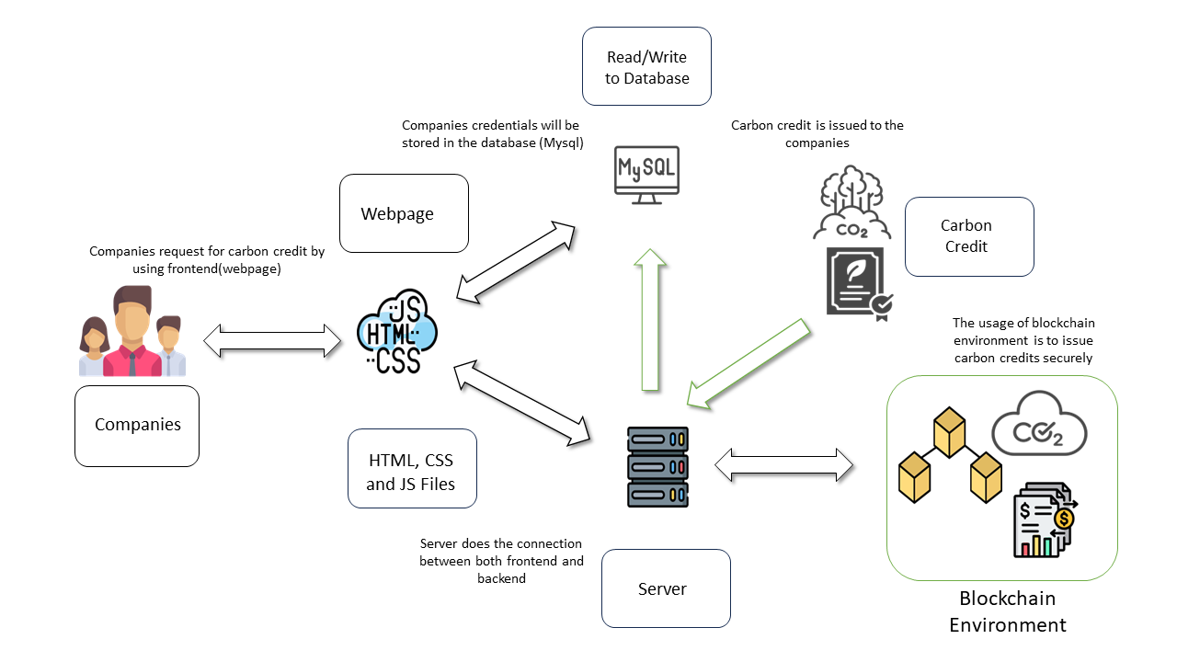
Figure 2 - System architecture

This architecture involves lots of procedures. Let’s suppose some x company wants to buy carbon credit. The x company would approach the website which is frontend built up with HTML, CSS, JavaScript, and react.js. This website is attached with a server which is attached with the backend. Backend has interesting plots where we use some techniques like PHP, react.js, MySQL, smart contracts, ganache, truffle etc.
Developing all these has various stages to look upon. Let’s dive into it.

Various Stages

Developing any platform needs lots of research and planning. The ideology behind this project should be brought up as such, without any mutations in the ideology and the working, so we need to develop so much knowledge on topics like carbon credits, climate change, the impact of industries on the environment, geography, and technologies like react.js, node.js, blockchain, etc.
Later, drawing is a blue-print is must to execute any ideology in any form. That should look like the system architecture mentioned above. Choosing the correct platform is very much essential thing to develop any project properly. A proper development tool will allow us to develop the best software on our own. The environment that we use should be compatible to work in blockchains such as Ethereum or Polygon, etc., that is the development platform should be able to develop smart contracts, make transactions, set up and develop API and ABI for the websites, and so on.
Planning and writing the smart contract’s need on a paper with pen is essential before directly deploying the smart contract. Because it will be a waste to deploy before knowing what to do and how to do it on an original platform. Even though we are going to deploy using a test net (i.e.) using a testing network, it is advised to do rough work on a paper. Later, develop the smart contract using any of the languages you are familiar with such as – Solidity, Vyper, and even Python. Later attach this work to the frontend where we have lots of functionalities for the end users(clients).
Continuous testing and development of the website and the working of the networks should be done in to achieve the perfection of the website and smart contract.
The customer’s feedback is an important factor for the development of the website and the smart contract.
These stages outline the key steps in developing and implementing the blockchain-based carbon credit trading platform efficiently.

Working principles

Let’s discuss the working of the backend in this project. The backend of this trading platform is based on blockchain. We very well know that blockchain makes P2P transactions where there are no intermediaries to hold the money. It is like giving money to another person directly from your pocket. Here we call the pocket in the shirt as a wallet that has some x money in different forms, we call them tokens (NFT- Non-Fungible Tokens).
Through this blockchain technology, we learned that we can make numerous amounts of transactions where it will be stored in a distributed ledger. In the environment where we develop this platform, we should have already installed Node.js, Truffle, Ganache, Open Zeppelin, etc.
The working of transactions will be in the following way, let’s say some A wants to send ETH to some B. A will initiate the transaction, and both A and B will have their wallet address through which money should be transacted. A will be receiving the Wallet address of B. To store A’s transaction a block will be created, other peers that are nodes will validate the transaction then, B will receive money. The transaction is ended. The transaction is stored in the block and the block is added to the blockchain.

Now to do this transaction in the ERC network, the network will have a smart contract in default. This smart contract is immutable once it is deployed into the network. After deploying our needed smart contract into any network, we have to test it using the test net.

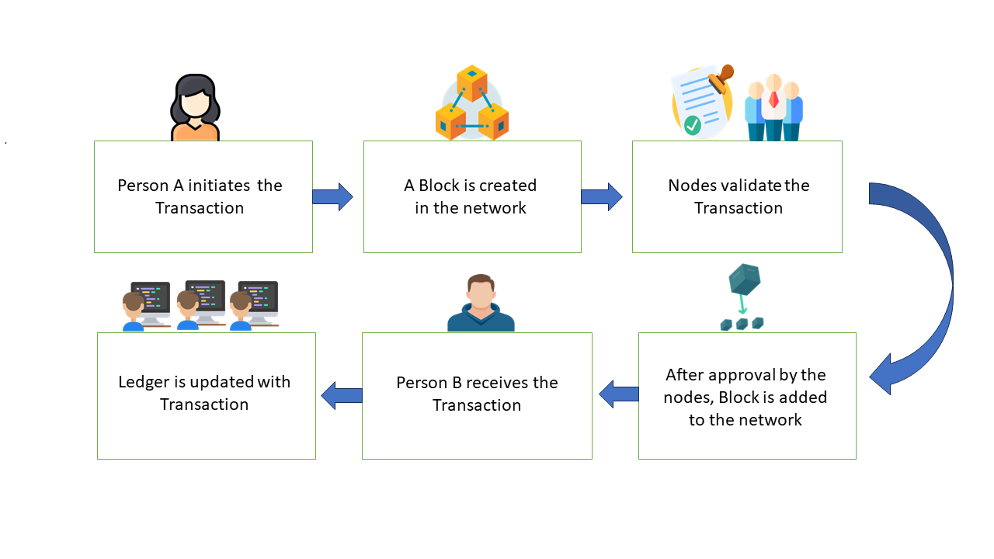
Figure 3 - P2P Transaction in Blockchain

Now the carbon credit trading platform smart contract should be added to the frontend using any database server like MySQL or PHP. Now every part of the application should be continuously tested and developed to maintain integrity. The backend doesn’t only contain smart contracts as the whole thing, we have to run ganache cli, truffle, and run in Node.js. while executing the truffle we can use many commands to shift through networks in which the smart contract should be executed.

Novelty of the proposal

The proposal introduces a novel approach to carbon credit trading by integrating blockchain technology, specifically, this platform will allow anyone to execute the smart contract in any network, mostly through sepolia, polygon, ERC20, etc.,
This unique market entry targets the underrepresented Indian market, offering transparency, security, and efficiency in trading.
By leveraging blockchain's transparency and decentralized governance, the platform fosters trust among stakeholders and promotes environmental impact through emissions reduction and renewable energy investment.

Conclusion
As we reach the conclusion point, we can summarize that there are several networks available to execute the smart contract we want. Here, through this project, we are trying to rebalance the carbon levels in the atmosphere just by using renewable energy or any carbon-absorbing activities through the incentives provided by the companies who buy these credits through blockchain technology, while they produce too much GHG into the atmosphere.
This would impact both the environment and the industries' development in a better way. This sustainable management would need not compromise any development as well as pollution in the atmosphere.
Acknowledgment
We want to express our gratitude to our professor and the Institute, who guided us through this project. Their technical skills and approach towards innovation have transformed abstract ideas into a real-time platform.
References
- Cowls, J., Tsamados, A., Taddeo, M., & Floridi, L. (2021). The Ai Gambit: Leveraging artificial intelligence to combat climate change—opportunities, challenges, and recommendations. AI & SOCIETY. https://doi.org/10.1007/s00146-021-01294-x
- Sharma, B. (2021). The concept of Carbon Credit in the construction industry: A case study of viAct's scenario-based AI in carbon credit management. ResearchGate. https://www.researchgate.net/profile/Baby-Sharma3/publication/359618671_The_concept_of_Carbon_Credit_in_the_construction_industry_A_case_study_of_viAct's_scenario_based_AI_in_carbon_credit_management/links/624583cb21077329f2e48203/The-concept-of-Carbon-Credit-in-the-construction-industry-A-case-study-of-viActs-scenario-based-AI-in-carbon-credit-management.pdfH. Poor, An Introduction to Signal Detection and Estimation. New York: Springer-Verlag, 1985, ch. 4.
- Yuting Pan, Xiaosong Zhang, Yi Wang, Junhui Yan, Shuonv Zhou, Guanghua Li, Jiexiong Bao, Application of Blockchain in Carbon Trading, Energy Procedia, Volume 158, 2019, Pages 4286-4291, ISSN 1876-6102, https://doi.org/10.1016/j.egypro.2019.01.509.Coindesk. (2024, February
- A Crypto Carbon Credits Exchange is Created in Germany. Retrieved from https://www.coindesk.com/business/2024/02/06/a-crypto-carbon-credits-exchange-is-created-in-germany/
- A. Diabat, T. Abdallah, A. Al-Refaie, D. Svetinovic and K. Govindan, "Strategic Closed-Loop Facility Location Problem With Carbon Market Trading," in IEEE Transactions on Engineering Management, vol. 60, no. 2, pp. 398-408, May 2013, doi: 10.1109/TEM.2012.2211105. keywords: {Supply chains; Carbon dioxide; Companies; Recycling; Raw materials; Carbon; Green products; Carbon credits; closed-loop supply chain; disposal; flexible legislation; recycling; remanufacturing; reverse logistics}
- Lei Wang, Chenyu Yang, Zhilong Xu, Guilin Yuan, Liang Tang, Yunlong Bai, Xuli Wang, Analysis of carbon electricity coupled market modeling method based on carbon credit trading mechanism, International Journal of Electrical Power & Energy Systems, Volume 156, 2024, 109707, ISSN 0142-0615, https://doi.org/10.1016/j.ijepes.2023.109707.
- W. Chen, Y. Zhang and H. Yang, "The Impact of Cap-and-Trade Mechanisms and Bank Credit on Renewable Energy Investment," in IEEE Transactions on Engineering Management, vol. 71, pp. 7379-7394, 2024, doi: 10.1109/TEM.2023.3245088. keywords: {Renewable energy sources; Investment; Emissions trading; Carbon dioxide; Generators; Government; Carbon tax; Bank credit; cap-and-trade mechanisms; renewable energy investment}
- G. Lakshmi and G. Thiyagarajan, "Decentralized Energy To Power Rural Homes Through Smart Contracts And Carbon Credit," 2021 7th International Conference on Electrical Energy Systems (ICEES), Chennai, India, 2021, pp. 280-283, doi: 10.1109/ICEES51510.2021.9383683. keywords: {Renewable energy sources;Technological innovation;Wind energy; Blockchain; Internet of Things; Solar panels; Carbon; blockchain; decentralized energy; carbon credits; smart contracts}
- L. F. Santos, J. Gomes, R. Braga, J. M. N. David and V. Stroele, "Towards a SECO for Carbon Credit Control," 2023 IEEE/ACM 11th International Workshop on Software Engineering for Systems-of-Systems and Software Ecosystems (SECoS), Melbourne, Australia, 2023, pp. 13-21, doi: 10.1109/SESoS59159.2023.00008. keywords: {Economics; Greenhouse effect; Ecosystems; Carbon dioxide; Soil; Climate change; Global warming; Carbon tax; Blockchains; carbon credit; SECO; provenance; blockchain},
- S. Danish, et al.,"Blockchain for Energy Credits and Certificates: A Comprehensive Review" in IEEE Transactions on Sustainable Computing, vol., no. 01, pp. 1-13, 5555. doi: 10.1109/TSUSC.2024.3366502 keywords: {climate change; emissions trading; green design; renewable energy sources; environmental monitoring; greenhouse gases; carbon emissions; blockchains; certification; sustainable development; energy management; energy dissipation}https://doi.ieeecomputersociety.org/10.1109/TSUSC.2024.3366502

 

